Helping you save time and money.

The Capitol Region Education Council (CREC) is a member of the Association of Educational Purchasing Agencies. This group of 26 state educational service agencies bids nationally on behalf of the schools, municipalities, and non-profit organizations in their respective states. The following is a current list of contracts available through CREC in Connecticut and throughout New England.

Athletic Lighting | Techline Sports Lighting
Althetic Surfaces – Tracks/Courts | FieldTurf USA | Hellas Construction
Athletic Surfaces – Turf Fields | FieldTurf USA | ProGrass
 | UBU Sports | The Motz Group
 | Shaw Sports Turf
Classroom & Office Supplies | Quill Corporation
Copiers/Multifunction Machines | Konica Minolta | Kyocera Mita
Custodial Equipment | Nilfisk-Advance (Clark equipment)
Custodial, Rest Room, Break Room and Safety Supplies | Quill Corporation
Digital Resources | Mackin Educ. Resources | Teachingbooks.net
Facility Management Software | SchoolDude for schools | FacilityDude for towns
Industrial Arts, Career and Tech Ed | Midwest Technology Products
Interactive Classroom and Presentation Equipment | Troxell Communications
Kitchen Supplies | Quill Corporation
Maintenance, Repair and Operations | Sherwin Williams (paint)
Roofing | WTI/Tremco
School Furniture | Interior Systems
Scoreboard & Marquis Signage | Daktronics
Security – Metal Detectors and Live Finger Print and Palm Screening | CEIA USA | Identification Int’l
Technology Catalog | CDW-G | MNJ Technologies

For more information about these vendors, including contact information,
visit our website at www.crec.org/coop.

For more information about AEPA and the bid process, visit www.aepacoop.org
or contact Cara Hart at 860-524-4021 or chart@crec.org.

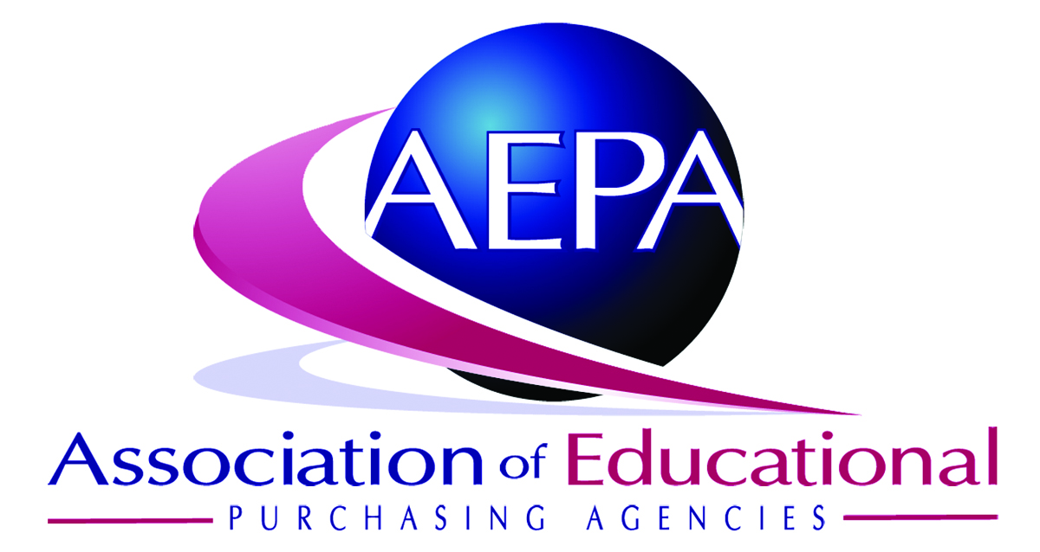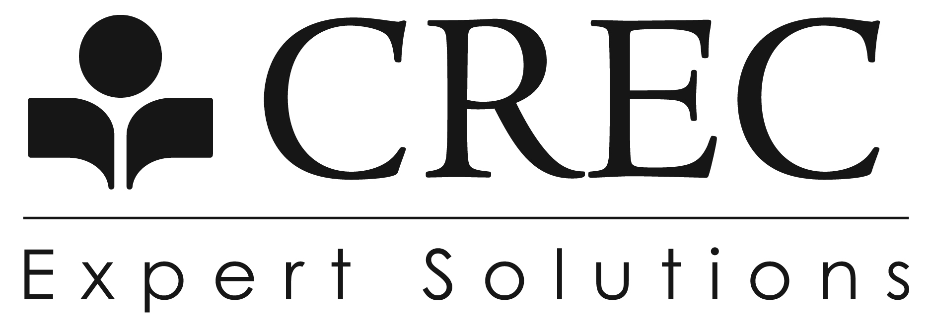

Helping you save time and money.

The Association of Educational Purchasing Agencies (AEPA) is a nationwide group of educational organizations working collaboratively to save time and money for school districts, municipalities, and non-profit organizations. AEPA has more than $350 million in annual protected purchases. We are currently 26 members strong, representing schools serving more than 25 million students.

Of the many advantages to this unique purchasing group are the combined human resources with purchasing experience, bidding expertise, vendor relationships, and overall vision with regard to the needs of the customers within each represented state. AEPA is unique in that each purchasing contract is awarded separately in each member state, in accordance with local bidding laws, resulting in state-specific bid protection. Local support from our member agencies sets up apart from other national cooperatives.

Program Advantages:

- Leveraged purchase power benefits all schools, municipalities, and non-profit organizations, regardless of size, by providing the ability to purchase at equal buying levels

- Combining the potential needs of all schools, municipalities, and non-profit organizations creates an incentive for vendors to offer the best price and highest quality product

- Streamlined bidding and purchase process through a single legal purchasing solicitation recognized locally and nationally

- No expense of going through a bid process and no duplication of efforts

- Volume contracts based on 26-state participation

- Detailed and complete bid process through nationally experienced participants

Our mission is to cooperatively serve our customers through a continuous effort to explore and fulfill present and future purchasing needs. We will work on your behalf to secure multi-state, volume purchasing contracts that have benefits that are measurable, cost-effective and continuously exceed our membership’s expectations.

For more information, contact Cara Hart at 860-524-4021 or chart@crec.org.
Please see reverse side for a list of qualified vendor contracts.

