Association Montessori Internationale Assistants Training Course
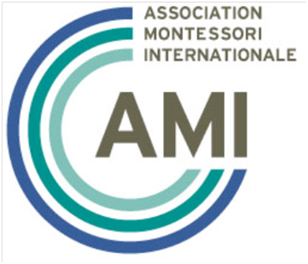
Sponsored by MTCNE

Monday and Wednesday 2:00 pm- 6:00 pm
October 29 to December 22, 2014
Presenter Uma Ramani, AMI Primary Trainer

The Montessori Training Center of New England (MTCNE) is pleased to offer the Association Montessori Internationale (AMI) Primary Assistants Training Course directed by AMI Primary Trainer, Uma Ramani. The course consists of class lectures, discussions and activities. Participants must also log 9 additional hours of observation in Montessori Primary and Elementary classrooms. Readings and three written papers will be assigned throughout the training. Participants successfully completing the course will be awarded an AMI Primary Assistants Course Certificate.

This course will:
- Give you an introduction to Montessori education
- Give you a basic understanding of children and how they learn
- Introduce you to the Montessori classroom environment
- Help you understand how adults support learning in the Montessori classroom
- Introduce you to the role of the Assistant in a Montessori classroom
- Give you practical guidelines on how to interact with children
- Give you practical guidelines on how to support the Guide in the Montessori classroom

Dates:
October 29 – December 22, 2:00 pm – 6:00 pm, Mondays and Wednesdays
(no class on November 26)
60 hours total class time plus 9 hours additional observation time
Complete all course requirements by December 22
Certificates will be awarded on December 22 for those completing all requirements

Location:
The course is offered by the CREC Montessori Training Center of New England (MTCNE), and will be held at CREC Montessori Magnet School at 1460 Broad St, Hartford, CT 06107.

Tuition for course is $800 plus cost of books
(Special tuition discount for CREC or Hartford Public School Employees - $700)

For more information contact Courtney Reim at medmtcne@hartford.edu or call 860-509-3687.

To register go to the CREC web address below, scroll down to AMI Assistants Course Training and click on “REGISTER”: http://www.crec.org/tls/events/index.php



