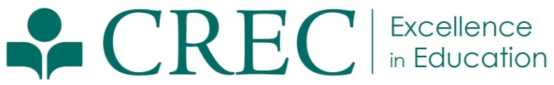
Press Release

FOR IMMEDIATE RELEASE  April 28, 2014 | Julia Winer  Assistant Director of Communications  (860) 509-3666  jwiner@crec.org
CREC Arts Academy Wins Best Of Hartford Award
for Second Year in a Row
(Hartford, CT) On April 24, the CREC Greater Hartford Academy of the Arts was announced as the winner of in the 11th Annual 2014 Best of Hartford Magazine readers poll for Best Magnet School. Over the last few months, Hartford Magazine has been asking readers throughout Connecticut to vote for their favorite food, drinks, retailers, service providers, entertainment, and people of Greater Hartford.

“I’m so pleased that the Academy won this award for the second consecutive year because it shows that the parents and families of our students feel that we are giving them the tools they need to succeed after high school and in their future endeavors,” said Kim Stroud, Director of Arts at the CREC Academy of the Arts. “The fact that the parents and families took the time to vote for the Academy speaks volumes on the excellent job being done by our faculty and staff”

The CREC Greater Hartford Academy of the Arts is known for its world-class artistic programing for students in middle and high school grades. Last year, the Academy won the Best Magnet School award for the first time. This year’s awards were officially announced in the May issue of Hartford Magazine, available on newsstands now.

###

The CREC Greater Hartford Academy of the Arts is an interdistrict magnet high school that offers both full-day and half-day programs for students throughout Greater Hartford. For more than 25 years, the Academy has focused on developing the fullest academic and artistic potential in all students, encouraging them to be creative, engaged citizens, and preparing them to pursue careers in the arts. Art classes are offered in creative writing, dance, inter arts, theater, technical theater, music (vocal and instrumental), musical theater, and visual arts.

The Capitol Region Education Council was established in 1966. Working with and for its member districts, CREC has developed a wide array of cost-effective and high-quality programs and services to meet the educational needs of children and adults in the region. CREC regularly serves 36 towns in Greater Hartford, offering more than 120 programs to more than 150,000 students annually. CREC manages more than 35 facilities throughout the area, including 19 interdistrict magnet schools. More information about CREC or CREC’s award-winning Magnet Schools is available at www.crec.org.

